Author/s: Rishav SinghShivam Shah
Team/Pod: Payouts| BU: RazorpayX
Published Date: Oct 7, 2024

Reviewer Name | Reviewed Date | Status
 |  | Not started
 |  | Not started

1. Problem Statement
There is a frequent requirement for performing data fixes on API and Payouts databases to resolve recurring production issues. Previously, these fixes were carried out using the dark-api pipeline, where the necessary changes were made in a temporary branch (Payouts-api-fixes). This code was merged into the current dark branch and deployed with approval through a dark-api pipeline. However, as of October 1, 2024, this practice has been discontinued (reference: thread).
The immediate need is to create a Payouts Manual Actions Dashboard on the Admin Dashboard. This dashboard will allow authorized team members to execute manual actions in production for resolving Payout-related issues without requiring dark-api deployments.

2. Background

2.1 Dark Manual Actions
Some of the key manual actions frequently required by the Payouts team which were done through dark-api pipeline include:
- Manually Dual Write Payouts between PS (Payout Service) and API: This action ensures that payout information is synced between the Payout Service and the API, especially when automatic syncing has failed or needs to be re-triggered.
The frequency of such cases has been vastly reduced in the last few weeks, but we are still getting some cases like these.
- Move API Payouts Status from Processed to Processing: This is required when payouts are incorrectly marked as processed due to premature updates, and they need to be reverted to an earlier state for reprocessing.
These cases happen when the bank sends us a processed/failed response via API and we mark it in terminal state. However, later on when we receive a request from FinOps to change the status based on the account statement.
Along with the action we are also planning to include a key “reason” to know the reason for this action being used, so that later on we can check out the reason for using this action .
- Move PS Payouts Status from Processed to Processing: Similar to the API Payouts status change, this action is used to reset Payout Service payouts to a processing state.
- Manually Approve / Reject Workflow for Payouts: Sometimes payout workflows get stuck in approval stages or require manual intervention. This action allows team members to manually approve such workflows, bypassing automatic approvals that may not be functioning properly.
Due to some system changes and issues, we see that the approval for workflow payout gets missed, we need to manually approve or reject workflow for payouts in that case.
- Credit Note generation: The finance team requires credit note generation for situations where a merchant has received an invoice for a total amount (e.g., ₹100) but has only paid a partial amount (e.g., ₹70). To ensure that we do not incur a tax loss on the remaining balance (₹30), it is necessary to generate a credit note. This functionality should be treated as a feature, not a fix/ad hoc.
- Payout Link status update: An update on payout link status is necessary whenever a payout is stuck in an incorrect state, which may occur due to system failures or unhandled cases. Previously, this status was determined through a database query. The frequency of these requests has risen, particularly because customers are increasingly choosing to receive payouts in their Amazon wallets for a specific merchant.
- Process Bank Transfer: When a pod goes down or an internal error occurs, bank transfers may not get processed and can remain in a "created" state. In such cases, manual intervention is required to resolve these transfers using dark.
The reason for using dark flow is that the normal processing flow includes a duplication check. If a bank transfer already exists in any state, the system will reject the new request. To handle the transfers that are stuck, we have a separate action that bypasses the duplication check, allowing us to process these transfers manually.
- Merchant Invoice generation: Merchant invoice generation is necessary when the automated invoice creation process fails for a specific merchant during a scheduled cron job. It’s important to note that this code flow interacts directly with the master database, which may result in increased load on the system.
- Fee Recovery Status Update: An update on fee recovery status is necessary for manually tracking the status of fee recoveries. Whenever a fee is settled, its payout ID is recorded in a table for reference. However, in the case of manual fee recovery, we sometimes store not only the payout ID but also alternative reference values such as UTR (Unique Transaction Reference) and other identifiers in the payout_id field.
- Redis Get & Set: These are required because dev doesn’t have access to view redis values and has to rely on Ops for it.
- DB Queries?:

2.2 How are Payouts marked Processed to Failed/Reversed ?
As mentioned in the Move API Payouts Status from Processed to Processing action above, there are cases where FinOps raise a request to PSE / on-call Devs to move payouts status from processed to failed/reversed after they analyze account statements. We perform following operations to do this action :

2.2.1 Move Payouts Status from Processed to Processing : This action is done through running update queries on API / Payouts DB. Some set of queries are provided to do this action through API curls :

"update payouts set status = 'initiated', failed_at = null, reversed_at = null, status_code = null, failure_reason = null, remarks = null where id = <payout_id>",

"update fund_transfer_attempts set `status` = 'initiated' where id = <fta_id>",

"delete from payouts_status_details where id = <payout_status_details_id> and status = 'processed'"

2.2.2 Change FTS Transfer and Attempts status : We use “Manual Queries Update” action on the FTS dashboard of Admin Dashboard to change the status of related transfer and attempts manually to failed/reversed.
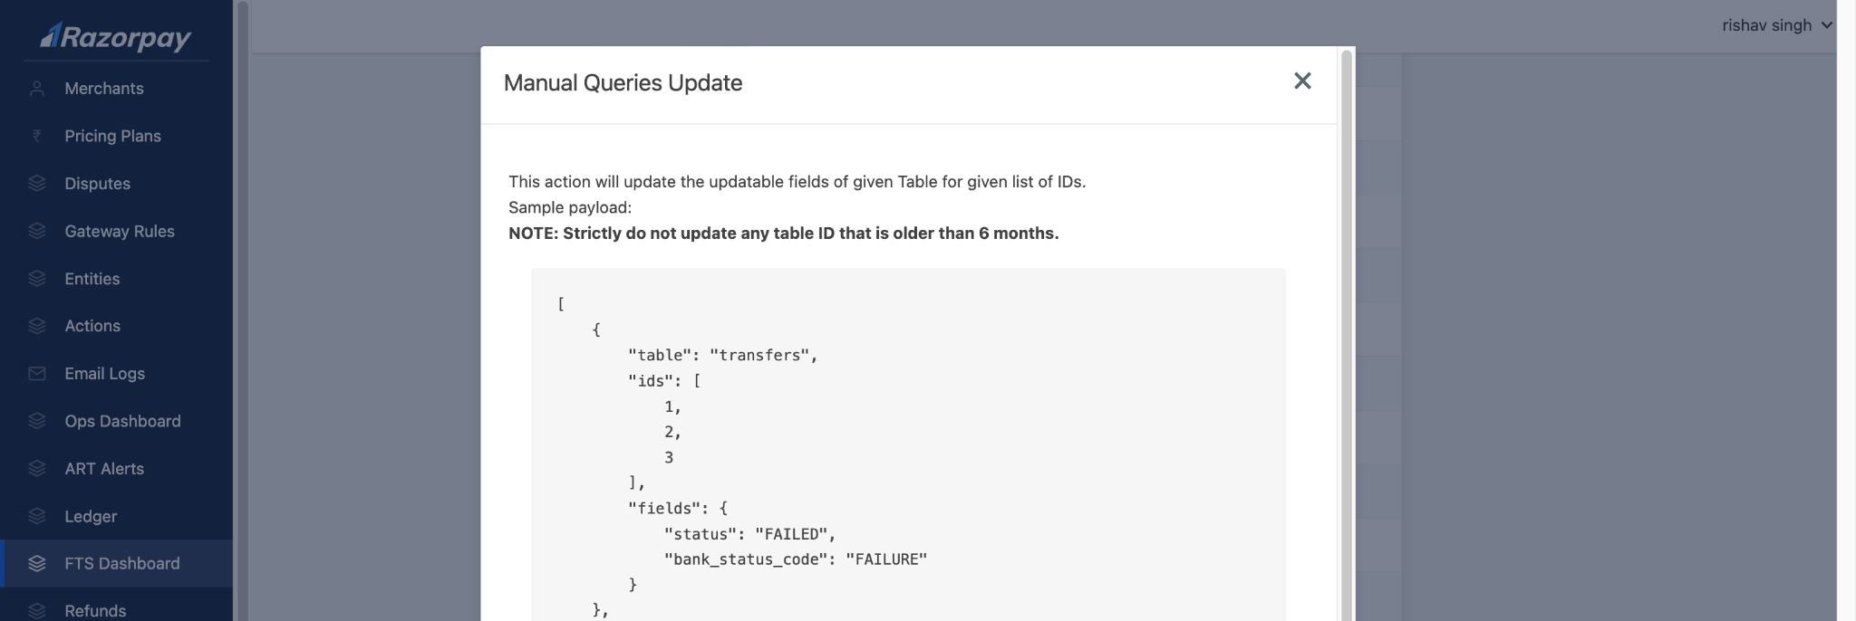

2.2.3 Sync FTS Status to Payouts : Once the failed/reversed status is updated on FTS, this needs to be synced with Payouts, for this a separate manual action of FTS Dashboard : Update Source with Fund Transfer Data is used.
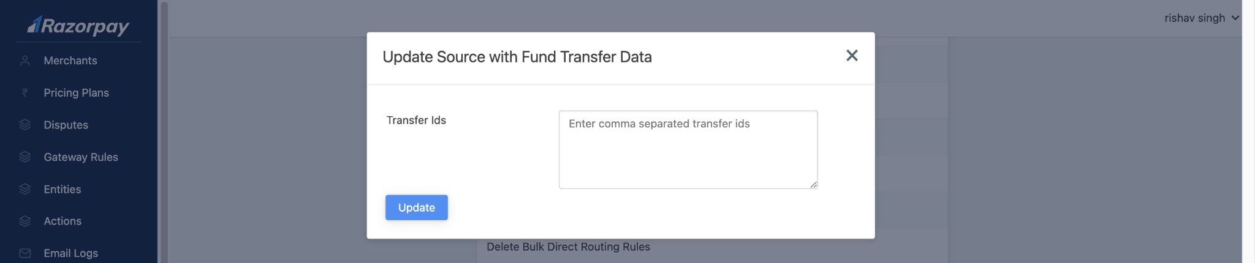

Based on the above steps done each payout statuses are moved.

This setup, while effective, introduced complexity and potential delays, as it required multiple steps (merging, approvals and deployments). Moreover, dark deployments were prone to risk, making the system open to certain potential issues.
By transitioning to a dashboard-based approach, we aim to:
- Provide a self-service UI for authorized users to fix Payout-related issues.
- Minimize the need for dark deployments and reduce associated risks.
- Comply with the org wide reduction of usage of dark-api pipeline.
- Streamline operations with well-defined actions directly through the Admin Dashboard.

3. Approach
To enable the Payouts team to handle production issues without relying on dark-api pipelines, we are creating a Payouts Manual Action Dashboard within the Admin Dashboard. This dashboard will feature a dropdown menu for selecting actions that can be performed, along with an input field for JSON data and a submit button to trigger the action. The system will be flexible, allowing for the addition of future manual actions simply by including new options in the dropdown.

Sequence Diagram : Payouts Manual Action Dashboard
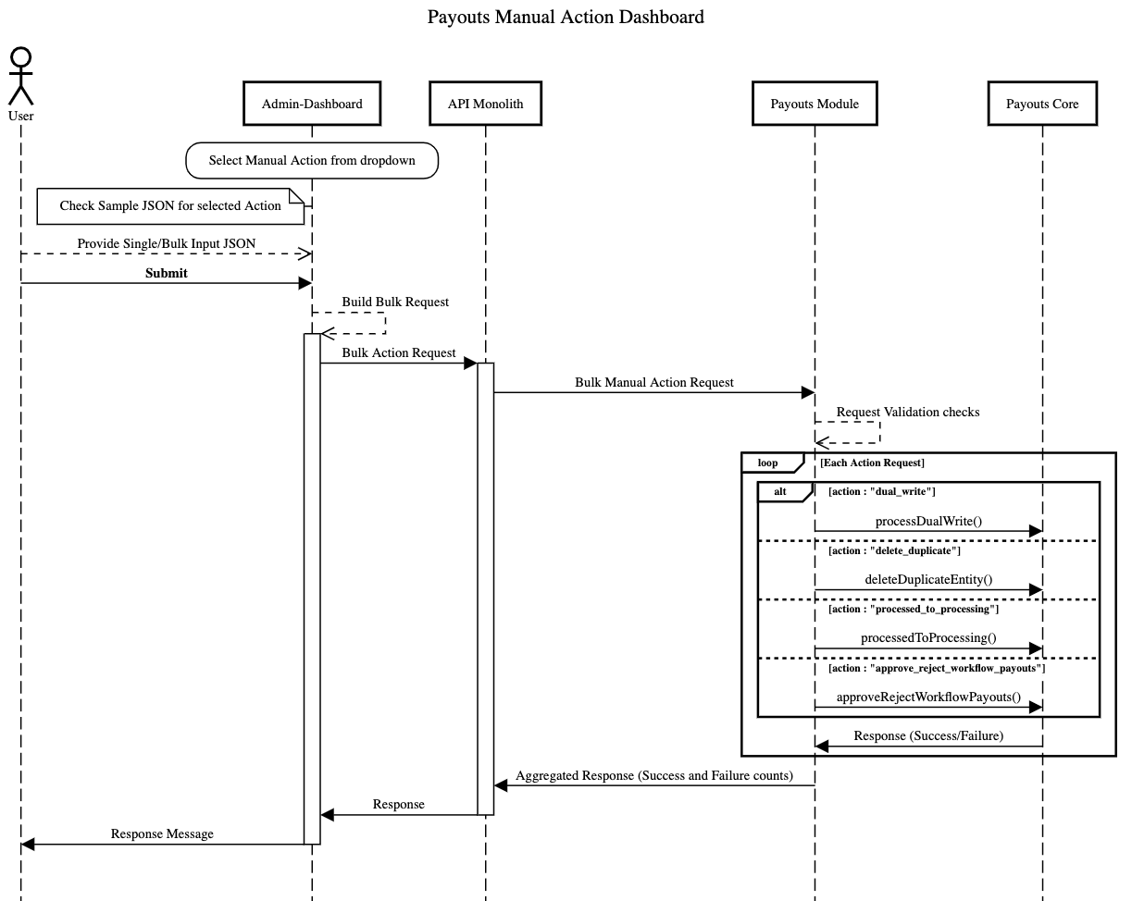

3.1 Frontend on Admin Dashboard
Option - 1 :
The frontend view will include:
- Actions Dropdown: A dropdown field to select the manual action. Each action mentioned in the background will be included here.
- Input Field: An input text field for JSON data that will be processed for the selected action.
- Submit Button: A button to trigger the action once the required data has been provided.
This means for every action we will have a generic input field that takes valid JSON as input and the User has to provide the key and value required for running the action. We can also show a sample json input for User’s ease for each action.
The dashboard will be scalable, allowing for the addition of new actions in the future by simply adding them to the dropdown and associating them with the backend logic.
Option - 2 :
The frontend view will include:
- Actions Dropdown: A dropdown field to select the manual action. Each action mentioned in the background will be included here.
- Customized Multiple Input Fields for every action: To have multiple input fields based on the type of action, For example to have fields like “is_payouts_service_payout” to denote the payout is from payouts_service.
- Submit Button: A button to trigger the action once the required data has been provided.
This approach will require more customized views for each of the actions, while we can make the backend code generic and extendible to any entity apart from what we are implementing, we have to make the frontend specific for each of the actions.
Final Approach :
We are going with the 1st option of keeping a generic FE for each manual, to accommodate any new changes or new action additions to be done in the future, so that the FE and API contracts are able to be extendable.

Phase -1 changes:
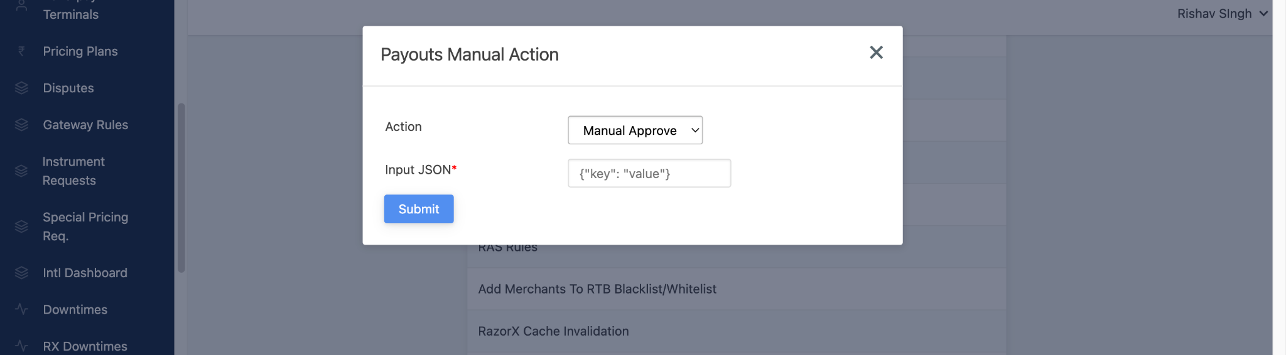

3.2 Backend on API Monolith
In the API monolith, a new route /payouts/manual_action has been created. This route will handle the execution of the manual actions passed via the dropdown. The route is flexible enough to process multiple manual actions, and additional actions can easily be integrated into the system as required.
- New Route: /payouts/manual_action
This route will dynamically handle the execution of actions specified in the dropdown.
- New Permission: A new permission, PAYOUTS_MANUAL_ACTION, has been introduced. Only users with this permission will be authorized to perform manual actions.
The actions passed via the dropdown will be processed by the backend, and the necessary logic will be executed based on the selected action.

3.3 Actions Explanation
Each action from the dropdown will trigger its corresponding logic on the backend. Below are short explanations of the current actions:

- Manually Dual Write Payouts between PS and API: Sync payout information between PS and API when automatic syncing fails.
  - Manually Triggers the pre-defined function processDualWrite for the specific payout_ids.
  - Validations and Failures will be handled by the pre build function as default, We will consume the success / failure response and return the same to the user.
- Move API/PS Payouts Status from Processed to Processing:
  - Validation & Pre-checks: The system validates the presence of critical fields— fta_id, and payout_status_detail_id through the provided payout_id in the input. Missing payout_id fields trigger a warning, ensuring that the action isn't executed without essential details.
  - Transaction is in place for this whole operation as we need to update multiple tables and everything will be rolled back in case of failure.
  - For status update of each entity a manual action state machine is in place to ensure valid state transitions
  - Payout Status Update: The status of the payout is updated from Processed to Initiated by resetting fields such as STATUS, FAILED_AT, STATUS_CODE, and FAILURE_REASON.
  - Fund Transfer Attempt (FTA) Update: The corresponding FTA entity is also updated, resetting its status to Initiated to match the payout's new state and allowing the system to retry the payout.
  - Status Detail Cleanup: Any existing payout_status_details entries marked as 'Processed' are deleted, ensuring no residual processed state exists in the system.
  - We will log the state change of all these actions along with the user triggering this action
  - HTTP call for PS payout: If is_payout_service is true, then otherwise, then a HTTP call is made to Payouts Service and same operations are applied to Payouts service DB like mentioned above for API DB ensure that transaction is maintained and over correct database.
- Manually Approve/Reject Workflow for Payouts: Approve stuck workflows requiring manual intervention.
  - Manually Triggers the pre-defined function processActionOnFundAccountPayoutInternal for the specific payouts with respective attributes
  - The Cross validation and Exception handling is handled by the prebuilt function, we are consuming the response of the pre built function and will forward this to the user.
- Credit Note Generation:
  - Input Data Validation: The system validates all required fields – invoice number, merchant_id, balance_id, taxable_amount, gst_amount, document_date. Any missing required field returns error and doesn’t execute the action.
  - Action: A credit note for the given amount and date will be generated corresponding to the merchant ID, balance ID and invoice number provided as input.
- Merchant Invoice Generation:
  - Triggers an already defined function createInvoiceEntities present in app/Models/Merchant/Invoice/Processor.php
- Payout Link Status Update:
  - Validation & Pre-checks: The system validates the presence of critical fields – payout_link_id and updated_status. Any missing field throws an error, and ensures that the action isn't executed without these details.
  - Transaction is in place for this whole operation as we need to update multiple entries across different databases, and everything will be rolled back in case of failure.
  - For status update of each entity a manual action state machine is in place to ensure valid state transitions
- Manual Process Bank Transfer:
  - Input Data check: Bank Transfer ID is the only input.
  - Action: Processes stuck fund transfers based on bank_transfer_id(s) provided.
- Fee Recovery Status Update:
  - Input Data Validation:
  - Dry Run:
  - Update:

3.4 API Contract for Actions
Overview:
API Backend Expects the following Requests and Response from the Frontend:

Request

POST payouts/manual_actions

{
"action": "string",
// The type of action being performed (e.g:"processed_to_prcessing")
"reason": "string"
// The reason for usage of the action(e.g Processed No Debits)
"bulk_input":
[
// An array of inputs in JSON changes based on the selected action
]
}


Response

[
"bulk_status": "string", // Can be: "success", "failed", "partial",
"success_count": "int", // Number of successful operations
"failure_count": "int", // Number of failed operations
"exceptions":
[
{
"input" : "json" // "failed"
"error": "string", // If an exception occurred
}
]
]


Action-Specific Input Structures

1. Move API Payouts Status from Processed to Processing
For updating payouts and related entities.
Action: processed_to_processing
Input Example:

"bulk_input": [
{
"payout_id": "string", // Payout ID to update
"is_payout_service": "boolean" // True if payout from Payout Service
}
]


2. Manually Approve/Reject Workflow for Payouts
For manually approving/rejecting workflow payouts that are stuck.
Action: approve_workflow_payouts / reject_workflow_payouts
Input Example:

"bulk_input": [
"payout_ids" : [] // array
]


3. Manually Trigger Dual Write
For triggering dual write for the payout.
Action: dual_write_payout
Input Example:

"bulk_input": [
"payout_ids": [] // Payout IDs for dual write processing
]


4. Credit Note Generation
For generating credit notes.
Action: generate_credit_note
Input Example:
"bulk_input": [
{
"merchant_id": string, // Merchant ID for Credit Note generation
"balance_id": string, // Balance ID
"invoice_number": string, // Invoice number for which CN is to be gene.
"taxable_amount": int, // Taxable Amount (in paise)
"gst_amount": int, // GST Amount (in paise)
"document_date": { // Date on generated CN
"day": int,
"month": int,
"year": int
}
},
{
"merchant_id": string, // Merchant ID for Credit Note generation
"balance_id": string, // Balance ID
"invoice_number": string, // Invoice number for which CN is to be gene.
"taxable_amount": int, // Taxable Amount (in paise)
"gst_amount": int, // GST Amount (in paise)
"document_date": { // Date on generated CN
"day": int,
"month": int,
"year": int
}
},
],
"action": "generate_credit_note",
"reason": "Credit note generation required by finance team according to XON-XXXX"

5. Merchant Invoice Generation
For generating missing merchant invoices.
Action: generate_merchant_invoice
Input Example:
"bulk_input": [
{
"month": int,
"year": int,
"merchant_ids": array of strings // Merchant IDs for invoice generation
},
{
"month": int,
"year": int,
"merchant_ids": array of strings // Merchant IDs for invoice generation
}
],
"action": "generate_merchant_invoice",
"reason": "Merchant invoice generation for XON-XXXX"


6. Payout Links Status Update
For updating incorrect payout link status.
Action: update_payout_link_status
Input Example:
"bulk_input": [
{
"payout_link_id": string, // Payout Link ID for status update
"updated_status": string // Merchant IDs for invoice generation
},
{
"payout_link_id": string, // Payout Link ID for status update
"updated_status": string // Merchant IDs for invoice generation
},
],
"action": "update_payout_link_status",
"reason": "Payout link status not updated. Updating status for XON-xxxx, XON-YYYY"


7. Manual Process Bank Transfer
To process bank transfers stuck in created state.
Action: manual_process_bank_transfer
Input Example:
"bulk_input": [
{
"bank_transfer_ids": ["bt_id_1", "bt_id_2"]
}
],
"action": "manual_process_bank_transfer",
"reason": "..."


Response Status Logic
- success: All actions completed successfully (failureCount === 0).
- failed: All actions failed (successCount === 0).
- partial: Some actions succeeded, and some failed.
- error: System or server-level error occurred during execution.

Example Request and Response
Request Example for deleting duplicate entities:

{
"action": "delete_duplicate_entities",
"input": [
{
"entity_id": "12345",
"entity_type": "fund_transfer_attempts",
"is_ps_entity": true
},
{
"entity_id": "67890",
"entity_type": "fund_transfer_attempts",
"is_ps_entity": false
}
]
}


Response Status Logic
- success: All actions completed successfully.
- failed: All actions failed.
- partial: Some actions succeeded, and some failed.
- error: System or server-level error occurred during execution.

Example Request and Response
Request Example for moving payouts from processed to processing:

{
"action": "processed_to_processing",
"reason": "raised by bank through finops"
"bulk_input": [
{
"payout_id": "12345",
"is_ps_entity": true
},
{
"payout_id": "6789",
"is_ps_entity": false,
},
]
}

Response Example:

{
"status": "partial",
"success_count": 1,
"failure_count": 1,
"exceptions": [
{
"input":{
"payout_id": "6789",
"is_ps_entity": false
},
"status": "failed",
"error": "Payout ID doesn't exists"
}
]
}
This API contract provides flexibility based on the action while ensuring the response structure remains consistent. Each action's input array can vary in terms of required fields, but the overall format is predictable for both request and response.

4. Error Handling and Notifications
- Success Notification: Users will be notified when the action has been successfully completed.
- Error Handling: If an error occurs during the execution of a manual action, detailed error messages will be displayed to help the user for each action in bulk to understand and errors are logged to further debug and resolve the issue.

5. Test Cases
All the Test Case are mentioned in this test cases sheet

6. Scope & Release
Phase - 1

- Actions :
- Move API Payouts status Processed to Processing (2.2.1)
- Dual Write Payout
- Approve Workflow Payouts
- Reject Workflow Payouts
- Manual Process Bank Transfer
- Authorization : PAYOUTS_MANUAL_ACTION permission based Authorization on API Monolith route.
- Backend Changes :
- /payouts/manual_action routes introduction.
- Payouts Manual Action development in API Monolith
- P0 Actions to be added to reduce dark-api usage
- Frontend Dashboard : Payouts Manual Action - Dropdown Action addition in the actions modal

Phase - 2

- Actions :
- Move Payouts Service - Payouts status Processed to Processing
- Delete Entity Action with specific role based Authorization
- Fee Recovery Status Update
- Payout Link Status Update
- Merchant Invoice Generation
- Credit Note Generation
- Authorization : Role Based Authorization Implementation for payouts/manual_actions route through AuthZ
- Backend Changes :
- HTTP Call to Payouts Service from Payouts Manual Action for PS related actions
- Implementation on Payouts Service for actions related to Payouts Service DB.
- Audit logs Table on Payouts Service to store the state change logs and user details , currently relying on coralogix which has a retention period of 3 months.
- Frontend Dashboard : Payouts Dashboard Modal creation, Shifting Payouts Manual Actions and all other Payouts related actions to this modal.

7. Roll Out Plan
The feature will be rolled out based on permissions. Only users with the permission : PAYOUTS_MANUAL_ACTION will have access to it.

Initially this permission will be assigned just to specific devs and then after proper devstack testing and prod testing, the permission will be assigned to the PSEs.

8. Roll Back Plan
The rollback will be managed through an on/off control mechanism. This can be implemented using either:
- DCS settings
Pros:
- Provides a reliable and well-structured configuration management system.
- Ensures robustness and maintainability, particularly for merchant-specific configurations.
Con:
- Requires updates to proto entities whenever a new action is introduced, adding development overhead.

- Splitz Experiment:
Pro:
  - Only updating the experiment is needed to toggle or change settings, making the process quicker.
Cons:
  - Less reliable for long-term storage of configuration values.
  - Not ideal for managing critical configurations

Toggling the action off will disable it entirely, regardless of user permissions. Alternatively, the feature can be rolled back by removing the PAYOUTS_MANUAL_ACTION permission.

